DEFINITIVE ACUTE STENT THROMBOSIS IN A PATIENT WITH NON-ST ELEVATION MYOCARDIAL INFARCTION
S. Zamin, G. Wilson, K. Suarez, K. Slicker
Baylor Scott & White Health/Texas A&M College of Medicine, TX, USA

Background: With incidence below 1%, acute stent thrombosis is an uncommon complication of percutaneous coronary intervention (PCI), and can occur despite the use of drug-eluting stents (DES) and dual anti-platelet therapy (DAPT).
Case: An 87-year-old lady with history of coronary artery disease and PCI presented with sudden onset chest discomfort, nausea, and dyspnea. Her electrocardiogram showed normal sinus rhythm without dynamic ST segment changes, but troponin levels increased to 0.30 after 6 hours. Treatment started with Heparin drip, Aspirin, Metoprolol, and Atorvastatin. She subsequently went for angiography revealing 95% stenosis of the proximal right coronary artery (RCA) as well as 90% in-stent restenosis of the posterior descending artery (PDA). Successful PCI was achieved with DES to the proximal RCA and balloon angioplasty to the PDA. She was then started on Aspirin and Plavix.
Clinical decision: Shortly after returning to the floor, she became diaphoretic and described sudden, severe back pain, with a blood pressure of 70/40 mmHg and a junctional bradycardic heart rhythm. Atropine was followed by a dopamine infusion. Electrocardiogram revealed elevation of the ST segment in leads III and aVF. A repeat angiogram revealed that the proximal RCA was entirely occluded, consistent with acute stent thrombosis. During revascularization, she went into asystole and return of spontaneous circulation was attained after 5 minutes. Repeat PCI was successful, but a temporary pacemaker was placed for junctional bradycardia and she required hemodynamic support with inotropes. Plavix was replaced with Brilinta. She was placed in the ICU, where over a 2 day period, the inotropes were tapered. Patient was later discharged home.
Conclusion: While rare, stent thrombosis can occur in the setting of appropriate therapy with DES and DAPT, and early detection is critical given high risk of mortality. This case demonstrates the importance of recognition and intervention of acute stent thrombosis.

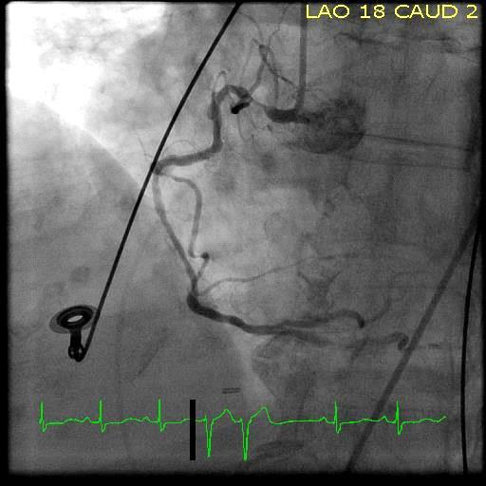
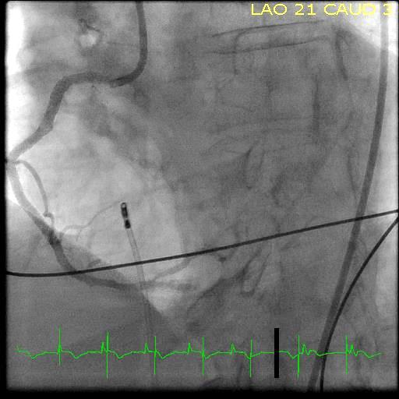
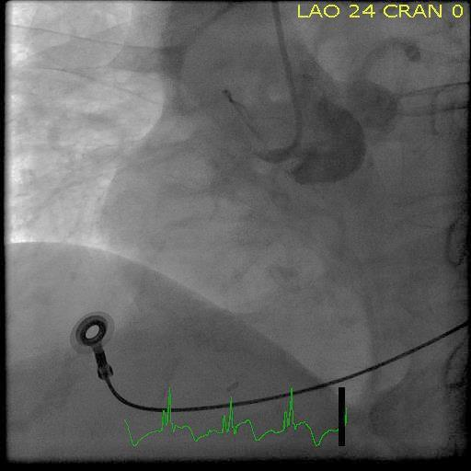
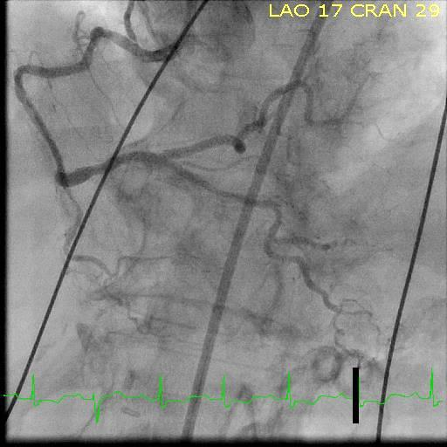
Figure 1. Initial angiogram of RCA
Figure 4. Repeat angiogram post PCI
Figure 3. Repeat angiogram stent thrombosis
Figure 2. Initial angiogram post PCI

